

**Lab Report 2**

**Submitted To**

**Faculty Name :** Md. Manowarul Islam

**Associate Professor, Dept. of CSE**

**Submitted By**

**Name :** Sheikh Sarafat Hossain

**Id No :** 2022-3-60-109

**Course Title :** Data Structures

**Course Code :** CSE207

**Section :** 07

**Semester :** Fall 2023

**Date of Submission:** 05 November, 2023

**Sorting and Matrix Operations in C++ Programming**

**Introduction:**

In this lab, I had the opportunity to explore the fundamental concepts of sorting elements in an integer array and performing various matrix operations using C++ programming. Gaining real experience with array and matrix programming while improving our problem-solving abilities was the main goal.

**Matrix Multiplication:**

In the first exercise, We discussed matrix multiplication in detail. We were given the option by the application to enter two matrices' dimensions and entries. We had the option of performing multiplication, subtraction, or addition. In addition to testing our knowledge of matrices, this exercise increased our ability to manage user input and apply mathematical operations to data. The outcome showed our skill in working with matrices and performing calculations.

The algorithms I used in my codes are given below :

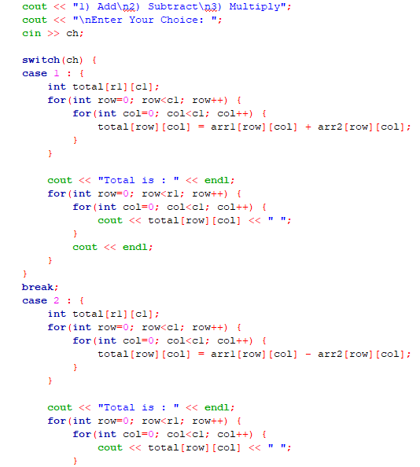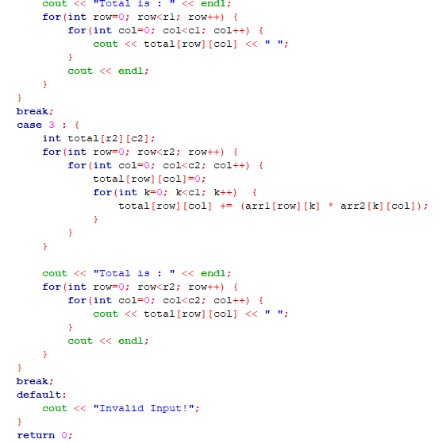

**Sum of Rows and Columns:**

In the second exercise, we learned to calculate the sum of elements in rows and columns of a matrix. By reading the matrix elements and presenting the sum of rows and columns, we gained a practical understanding of matrix traversal and the importance of structured data display. This exercise showed the importance of proper data collection and processing for complex computations.

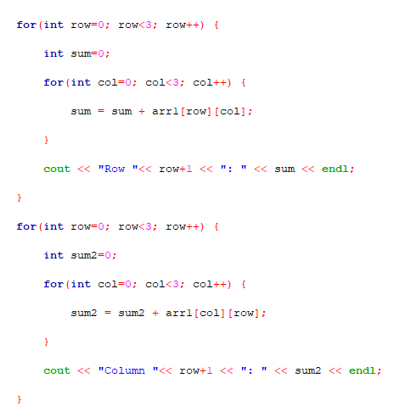

This is the algorithm I used in my code.

**Maximum Elements:**

The third exercise focused on finding the maximum elements in each row and column of a matrix. It was a valuable exercise in identifying extremal values within data. By locating the maximum elements in both rows and columns, we improved our array traversal skills and practiced comparing data values.

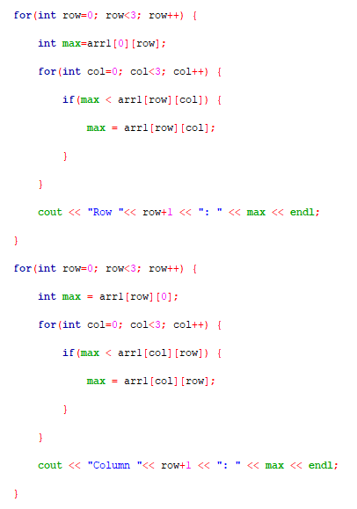

This is the algorithm I used in my code.

**Matrix Transposition:**

In the fourth exercise, we explored matrix transposition. This operation involves swapping rows and columns, fundamental in the realm of linear algebra. The program prompted us to enter the matrix elements and displayed the transposed matrix. We understood the concept of data rearrangement and developed skills in working with multidimensional data structures.

This is the algorithm I used in my code.

**Diagonal Elements:**

The fifth exercise was about extracting and displaying the diagonal elements of a matrix. This exercise sharpened our matrix traversal skills which also highlighted the need of careful data extraction. The diagonal elements showed our ability to identify certain data points inside a matrix.

**Identity Matrix:**

In the final exercise, we had to figure out whether a matrix is an identity matrix. This exercise showed the importance of pattern recognition and conditional statements. The output gave a clear indication of whether the matrix satisfies the requirements of an identity matrix.

This is the algorithm I used in my code.

**Conclusion:**

After completing this lab, I have the fundamental knowledge necessary for handling arrays and matrices using C programming. My understanding of input processing, mathematical computations, data traversal, and conditional expressions has all increased as a result of this fulfilling experience. These abilities are useful not only for this lab but also for solving problems in computer science and mathematics in the real world.

I now have a strong basis on which to build when I tackle more complex programming ideas like matrix algebra. I feel more confident now that I can apply these problem-solving techniques to a variety of computational difficulties thanks to this lab, and I'm forward to continue building on this foundation as I continue my programming career.